data augmentation CNN

Introduction
Deep Learning has become extremely popular in AI, and companies frequently employ its techniques to solve challenging real-world issues. This domain is progressing rapidly and finds applications in various use cases like self-driving cars, fraud detection, chatbots for customer service, sports analytics, natural language processing, and many more.
One typical limitation faced while training a deep learning model is the amount of data required. Deep learning models employ several different algorithms to make decisions. The required amount of data for training these models aren’t necessarily available for various reasons. New companies do not have any previous data, and data collection requires too much time and expertise. Besides, publicly available data might be limited or cannot be used due to privacy concerns.
One way to address this data shortage is to employ data augmentation and increase the size of the available data.

Why is Data Augmentation required?
Deep learning models are computationally expensive and require properly labeled data to perform well. To improve a model, we need to supply it with more data to identify more features to make a decision. Data augmentation can generate additional data from the existing data. It can improve the model accuracy and save time and money when gathering more real data is difficult.
Deep learning models are computationally expensive and require properly labeled data to perform well. To improve a model, we need to supply it with more data to identify more features to make a decision. Data augmentation can generate additional data from the existing data. It can improve the model accuracy and save time and money when gathering more real data is difficult.
What is Data Augmentation?
Data augmentation is a technique in deep learning to extend the original dataset by generating new training data from the existing data. The data augmentation tool transforms the data into fresh, unique samples by manipulating the parameters of the existing data. Data augmentation can be carried out for image, text, audio, and video inputs.
There are two types of data augmentation: offline (augmented images are stored on a drive and then combined with real data before training the model) and online (data augmentation is applied to randomly chosen images and used for training along with original data).
What are the benefits of Data Augmentation?
With correct implementation, data augmentation offers benefits -
● lowering the cost of data acquisition and data labeling
● improving model generalization by imparting more variety and flexibility to the model
● enhancing model accuracy in prediction as more data is used to train the model
● reducing overfitting of data
● handling imbalance in the dataset by augmenting the samples from the minority class
Image Data Augmentation techniques in Computer Vision
We can manipulate and transform the available images using the following techniques to create an augmented dataset using the following techniques. The two most commonly used types of transformations are — Geometric and Color transformations. To demonstrate these techniques, we will use a sample image from the Plant village dataset (without augmentation version)
Real-world examples of Data Augmentation
Data augmentation is currently being used across different industries, such as the manufacturing industry for quality inspection or defect identification, in Space agencies and Government organizations for assistance in analyzing satellite imagery for object detection.
An important application is the medical imaging domain in healthcare, where data privacy concerns are high and larger datasets for rare diseases are unavailable. Here, data augmentation is used to transform the medical images to add diversity to the original labeled dataset.
The agriculture domain also uses data augmentation to identify crop diseases and analyze the quality of the yield.
Image DA (Data Augmentation) libraries in Python
Data Augmentation is crucial in Deep Learning. Hence, most deep learning frameworks like Keras, Tensorflow, PyTorch, and more in Python include a few augmentation methods. Additionally, there are dedicated python libraries for image data augmentation like -
● OpenCV — a large open-source library that supports real-time image and videos processing for object and people detection
● Augmentor — is an augmentation package for machine learning that is platform and framework independent. It allows different augmentation methods to be executed in a pipeline.
● Albumentations — is a package that has a unified API, is fast, and supports more than 70 augmentation techniques for all computer vision tasks.
● AugLy- is a library developed by Facebook for social media applications. It has more than 100 augmentation techniques with support for image, text, audio, and video.
● Imgaug — is a library that supports several augmentation techniques and identifies image landmarks, bounding boxes, segmentation maps, and heatmaps.

Best practices in Data Augmentation
With multiple open-source tools available, generating additional data from existing data is certainly more accessible than acquiring additional real data. Although data augmentation is a powerful process, it needs to be used cautiously. Assessing the project requirements to evaluate the need for data augmentation is essential.
When applying data augmentation, we need to keep the following general guidelines in mind:
● Evaluate whether to use data augmentation; if images in dataset set < 100, use transfer learning and use the highly accurate pre-trained CNN models as feature extractors; else, go for data augmentation
● Decide the number of augmented images required, evaluate the existing hardware capabilities to generate these images
● Choose relevant augmentation techniques depending on the task.
● Use the optimum number of augmentation techniques by assessing which methods justify the real samples.
● Setting up systems to examine and evaluate the quality of the augmented dataset
● Develop relevant strategies to avoid the existing bias in augmented datasets.
● Be mindful of the time invested as the data augmentation process is time-consuming and expensive
● Display the samples of original and the augmented data in the notebook to ensure the pipeline worked correctly.

Benefits of data augmentation:
- Improved generalization: Data augmentation can help to improve a model’s generalization ability by making it more robust to different variations in the data. This is because the model is exposed to a wider variety of data during training.
- Reduced overfitting: Data augmentation can also help to reduce overfitting, which is a common problem in machine learning. Overfitting occurs when a model learns the training data too well and is unable to generalize to new data. Data augmentation makes the training data more diverse, which helps to prevent the model from overfitting.
- Increased accuracy: Data augmentation can often lead to improved accuracy on both the training and test sets. This is because the model is able to learn more robust features from a larger and more diverse dataset.
- Reduced cost: Data augmentation can be a cost-effective way to increase the size and diversity of a training dataset, especially for tasks where collecting new data is expensive or time-consuming.
Disadvantages of data augmentation:
- Increased computational cost: Data augmentation can increase the computational cost of training a model, especially for deep learning models. This is because the model needs to be trained on a larger number of images.
- Potential for introducing noise: If data augmentation is not used carefully, it can introduce noise into the training data. This can lead to decreased performance on the test set.
- Limited effectiveness for certain tasks: Data augmentation may not be effective for certain tasks, such as tasks where the data is already very diverse.
Overall, data augmentation is a powerful technique that can be used to improve the performance of machine learning models. However, it is important to use data augmentation carefully and to be aware of its potential disadvantages.
Some tips for using data augmentation effectively:
- Choose data augmentation techniques that are relevant to the task at hand.
- Don’t overuse data augmentation. Too much data augmentation can lead to decreased performance on the test set.
- Monitor the performance of the model on the test set to make sure that data augmentation is not introducing noise.

Image augmentation in Keras
Keras ImageDataGenerator class provides a quick and easy way to augment your images. It provides a host of different augmentation techniques like standardization, rotation, shifts, flips, brightness change, and many more. You can find more on its official documentation page.
However, the main benefit of using the Keras ImageDataGenerator class is that it is designed to provide real-time data augmentation. Meaning it is generating augmented images on the fly while your model is still in the training stage. How cool is that!
ImageDataGenerator class ensures that the model receives new variations of the images at each epoch. But it only returns the transformed images and does not add it to the original corpus of images. If it was, in fact, the case, then the model would be seeing the original images multiple times which would definitely overfit our model.
Another advantage of ImageDataGenerator is that it requires lower memory usage. This is so because without using this class, we load all the images at once. But on using it, we are loading the images in batches which saves a lot of memory.
Now let’s have a look at a few augmentation techniques with Keras ImageDataGenerator class.
Augmentation techniques with Keras ImageDataGenerator class
Random Rotations
Image rotation is one of the widely used augmentation techniques and allows the model to become invariant to the orientation of the object.
ImageDataGenerator class allows you to randomly rotate images through any degree between 0 and 360 by providing an integer value in the rotation_range argument.
When the image is rotated, some pixels will move outside the image and leave an empty area that needs to be filled in. You can fill this in different ways like a constant value or nearest pixel values, etc. This is specified in the fill_mode argument and the default value is “nearest” which simply replaces the empty area with the nearest pixel values.
# ImageDataGenerator rotation
datagen = ImageDataGenerator(rotation_range=30, fill_mode='nearest')
# iterator
aug_iter = datagen.flow(img, batch_size=1)
# generate samples and plot
fig, ax = plt.subplots(nrows=1, ncols=3, figsize=(15,15))
# generate batch of images
for i in range(3):
# convert to unsigned integers
image = next(aug_iter)[0].astype('uint8')
# plot image
ax[i].imshow(image)
ax[i].axis('off')
view rawrotation.py hosted with ❤ by GitHub
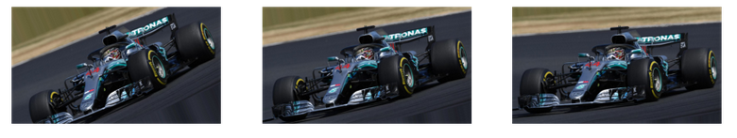
Random Shifts
It may happen that the object may not always be in the center of the image. To overcome this problem we can shift the pixels of the image either horizontally or vertically; this is done by adding a certain constant value to all the pixels.
ImageDataGenerator class has the argument height_shift_range for a vertical shift of image and width_shift_range for a horizontal shift of image. If the value is a float number, that would indicate the percentage of width or height of the image to shift. Otherwise, if it is an integer value then simply the width or height are shifted by those many pixel values.
# ImageDataGenerator shifting
datagen = ImageDataGenerator(width_shift_range=0.2, height_shift_range=0.2)
# iterator
aug_iter = datagen.flow(img, batch_size=1)
# generate samples and plot
fig, ax = plt.subplots(nrows=1, ncols=3, figsize=(15,15))
# generate batch of images
for i in range(3):
# convert to unsigned integers
image = next(aug_iter)[0].astype('uint8')
# plot image
ax[i].imshow(image)
ax[i].axis('off')
view rawshift.py hosted with ❤ by GitHub
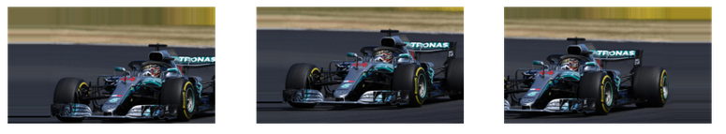
Random Flips
Flipping images is also a great augmentation technique and it makes sense to use it with a lot of different objects.
ImageDataGenerator class has parameters horizontal_flip and vertical_flip for flipping along the vertical or the horizontal axis. However, this technique should be according to the object in the image. For example, vertical flipping of a car would not be a sensible thing compared to doing it for a symmetrical object like football or something else. Having said that, I am going to flip my image in both ways just to demonstrate the effect of the augmentation.
# ImageDataGenerator flipping
datagen = ImageDataGenerator(horizontal_flip=True, vertical_flip=True)
# iterator
aug_iter = datagen.flow(img, batch_size=1)
# generate samples and plot
fig, ax = plt.subplots(nrows=1, ncols=3, figsize=(15,15))
# generate batch of images
for i in range(3):
# convert to unsigned integers
image = next(aug_iter)[0].astype('uint8')
# plot image
ax[i].imshow(image)
ax[i].axis('off')
view rawflip.py hosted with ❤ by GitHub
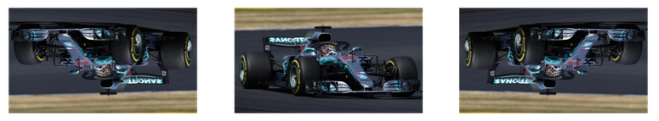
Random Brightness
It randomly changes the brightness of the image. It is also a very useful augmentation technique because most of the time our object will not be under perfect lighting condition. So, it becomes imperative to train our model on images under different lighting conditions.
Brightness can be controlled in the ImageDataGenrator class through the brightness_range argument. It accepts a list of two float values and picks a brightness shift value from that range. Values less than 1.0 darkens the image, whereas values above 1.0 brighten the image.
# ImageDataGenerator brightness
datagen = ImageDataGenerator(brightness_range=[0.4,1.5])
# iterator
aug_iter = datagen.flow(img, batch_size=1)
# generate samples and plot
fig, ax = plt.subplots(nrows=1, ncols=3, figsize=(15,15))
# generate batch of images
for i in range(3):
# convert to unsigned integers
image = next(aug_iter)[0].astype('uint8')
# plot image
ax[i].imshow(image)
ax[i].axis('off')
view rawbrightness.py hosted with ❤ by GitHub
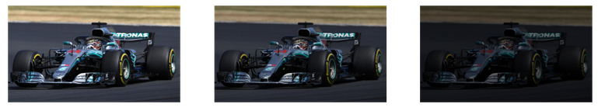
Random Zoom
The zoom augmentation either randomly zooms in on the image or zooms out of the image.
ImageDataGenerator class takes in a float value for zooming in the zoom_range argument. You could provide a list with two values specifying the lower and the upper limit. Else, if you specify a float value, then zoom will be done in the range [1-zoom_range,1+zoom_range].
Any value smaller than 1 will zoom in on the image. Whereas any value greater than 1 will zoom out on the image.
# ImageDataGenerator zoom
datagen = ImageDataGenerator(zoom_range=0.3
# iterator
aug_iter = datagen.flow(img, batch_size=1)
# generate samples and plot
fig, ax = plt.subplots(nrows=1, ncols=3, figsize=(15,15))
# generate batch of images
for i in range(3):
# convert to unsigned integers
image = next(aug_iter)[0].astype('uint8')
# plot image
ax[i].imshow(image)
ax[i].axis('off')
view rawzoom.py hosted with ❤ by GitHub
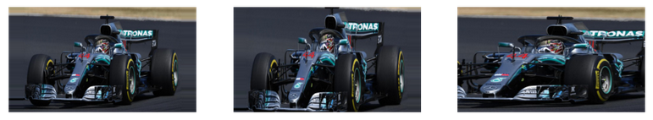
There are many more augmentation techniques that I have not covered in this article but I encourage you to check them out in the official documentation.
Introducing the Dataset
Before we explore the methods of the ImageDataGenerator class, let’s first get familiar with the dataset we will be working with.
We have a dataset of emergency (like fire trucks, ambulances, police vehicles, etc.) and non-emergency vehicles. There are a total of 1646 unique images in the dataset. Since these are not a lot of images to create a robust neural network, it will act as a great dataset to test the potential of the ImageDataGenerator class!
You can download the dataset from here.
ImageDataGenerator methods
So far we have seen how to augment images using ImageDataGenerator().flow() method. However, there are a few methods in the same class which are actually quite helpful and which implement augmentation on the fly.
Let’s first come up with the augmentations we would want to apply to the images.
# ImageDataGenerator
datagen = ImageDataGenerator(
rotation_range=10, # rotation
width_shift_range=0.2, # horizontal shift
height_shift_range=0.2, # vertical shift
zoom_range=0.2, # zoom
horizontal_flip=True, # horizontal flip
brightness_range=[0.2,1.2]) # brightness
view rawImageDataGenerator.py hosted with ❤ by GitHub
Flow_from_directory
The flow_from_directory() method allows you to read the images directly from the directory and augment them while the neural network model is learning on the training data.
The method expects that images belonging to different classes are present in different folders but are inside the same parent folder. So let’s create that first using the following code:
import pandas as pd
import os
import shutil
from sklearn.model_selection import train_test_split
# Home directory
home_path = r'C:/Users/Dell/Desktop/Analytics Vidhya/ImageDataGenerator/emergency_vs_non-emergency_dataset/emergency_vs_non-emergency_dataset'
# Create train and validation directories
train_path = os.path.join(home_path,'train')
os.mkdir(train_path)
val_path = os.path.join(home_path,'valid')
os.mkdir(val_path)
# Create sub-directories
emergency_train_path = os.path.join(home_path + r'/train','emergency')
os.mkdir(emergency_train_path)
non_emergency_train_path = os.path.join(home_path + r'/train','non_emergency')
os.mkdir(non_emergency_train_path)
emergency_val_path = os.path.join(home_path + r'/valid','emergency')
os.mkdir(emergency_val_path)
non_emergency_val_path = os.path.join(home_path + r'/valid','non_emergency')
os.mkdir(non_emergency_val_path)
# Original df
df = pd.read_csv(home_path + r'/emergency_train.csv')
# Images and Labels
X = df.loc[:,'image_names']
y = df.loc[:,'emergency_or_not']
# Train-Test splitfor train and validation images
train_x, val_x, train_y, val_y = train_test_split(X, y, test_size = 0.1, random_state = 27, stratify=y)
# Train df
df_train = pd.DataFrame(columns=['image_names','emergency_or_not'])
df_train['image_names'] = train_x
df_train['emergency_or_not'] = train_y
# Validation df
df_valid= pd.DataFrame(columns=['image_names','emergency_or_not'])
df_valid['image_names'] = val_x
df_valid['emergency_or_not'] = val_y
# Reset index
df_train.reset_index(drop=True, inplace=True)
df_valid.reset_index(drop=True, inplace=True)
# Save train images
for i in range(len(df_train)):
image = df_train.loc[i,'image_names']
if df_train.loc[i,'emergency_or_not'] == 0:
shutil.copy(home_path + r'/images/' + image, non_emergency_train)
else:
shutil.copy(home_path + r'/images/' + image, emergency_train)
# Save validation images
for i in range(len(df_valid)):
image = df_valid.loc[i,'image_names']
if df_valid.loc[i,'emergency_or_not'] == 0:
shutil.copy(home_path + r'/images/' + image, non_emergency_val)
else:
shutil.copy(home_path + r'/images/' + image, emergency_val)
view rawfolder_structure.py hosted with ❤ by GitHub
Now, let’s try to augment the images using the class method.
# ImageDataGenerator flow_from_directory
train_generator = datagen.flow_from_directory(
directory=home_path + r'/train/',
target_size=(400, 400), # resize to this size
color_mode="rgb", # for coloured images
batch_size=1, # number of images to extract from folder for every batch
class_mode="binary", # classes to predict
seed=2020 # to make the result reproducible
)
fig, ax = plt.subplots(nrows=1, ncols=4, figsize=(15,15))
for i in range(4):
# convert to unsigned integers for plotting
image = next(train_generator)[0].astype('uint8')
# changing size from (1, 200, 200, 3) to (200, 200, 3) for plotting the image
image = np.squeeze(image)
# plot raw pixel data
ax[i].imshow(image)
ax[i].axis('off')
view rawflow_from_directory.py hosted with ❤ by GitHub
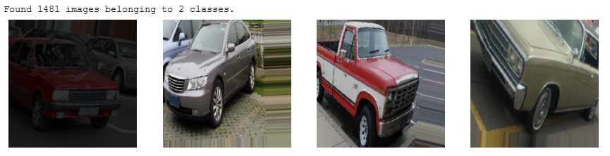
The following are few important parameters of this method:
- directory: this is the path to the parent folder which contains the subfolder for the different class images.
- target_size: Size of the input image.
- color_mode: Set to rgb for colored images otherwise grayscale if the images are black and white.
- batch_size: Size of the batches of data.
- class_mode: Set to binary is for 1-D binary labels whereas categorical is for 2-D one-hot encoded labels.
- seed: Set to reproduce the result.
Flow_from_dataframe
The flow_from_dataframe() is another great method in the ImageDataGenerator class that allows you to directly augment images by reading its name and target value from a dataframe.
This comes very handily when you have all the images stored within the same folder.
# ImageDataGenerator flow_from_dataframe
df_train = pd.read_csv(home_path + r'/emergency_train.csv')
df_train['emergency_or_not'] = df_train['emergency_or_not'].astype('str') # requires target in string format
train_generator_df = datagen.flow_from_dataframe(dataframe=df_train,
directory=home_path+'/images/',
x_col="image_names",
y_col="emergency_or_not",
class_mode="binary",
target_size=(200, 200),
batch_size=1,
rescale=1.0/255,
seed=2020)
# plotting images
fig, ax = plt.subplots(nrows=1, ncols=4, figsize=(15,15))
for i in range(4):
# convert to unsigned integers for plotting
image = next(train_generator_df)[0].astype('uint8')
# changing size from (1, 200, 200, 3) to (200, 200, 3) for plotting the image
image = np.squeeze(image)
# plot raw pixel data
ax[i].imshow(image)
ax[i].axis('off')
view rawflow_from_dataframe.py hosted with ❤ by GitHub
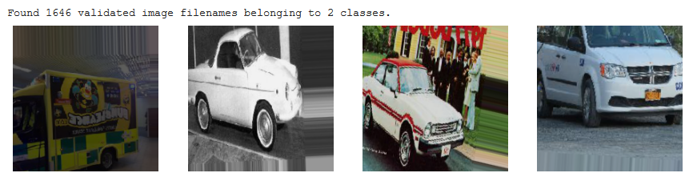
This method also has a few parameters that need to be explained in brief:
- dataframe: The Pandas DataFrame that contains the image names and target values.
- directory: The path to the folder that contains all the images.
- x_col: The column name in the DataFrame that has the image names.
- y_col: The column name in the DataFrame that has the target values.
- class_mode: Set to binary is for 1-D binary labels whereas categorical is for 2-D one-hot encoded labels.
- target_size: Size of input images.
- batch_size: Size of the batches of data.
- seed: Set to reproduce the result.
Keras Fit_generator Method
Right, you have created the iterators for augmenting the images. But how do you feed it to the neural network so that it can augment on the fly?
For that, all you need to do is feed the iterator as an input to the Keras fit_generator() method applied on the neural network model along with epochs, batch_size, and other important arguments. We will be using a Convolutional Neural Network(CNN) model. The fit_generator() method fits the model on data that is yielded batch-wise by a Python generator.
You can use either of the iterator methods mentioned above as input to the model.
# Augmenting on the fly with fit_generator()
# Directly use .flow()
model.fit_generator(datagen.flow(x_train, y_train, batch_size=batch_size),
epochs=epochs, # one forward/backward pass of training data
steps_per_epoch=x_train.shape[0]//batch_size, # number of images comprising of one epoch
validation_data=(x_test, y_test), # data for validation
validation_steps=x_test.shape[0]//batch_size)
# or use iterator from .flow_from_directory()
model.fit_generator(train_generator,
epochs=epochs, # one forward/backward pass of training data
steps_per_epoch=x_train.shape[0]//batch_size, # number of images comprising of one epoch
validation_data=(x_test, y_test), # Or validation_data=valid_generator
validation_steps=x_test.shape[0]//batch_size)
# or use iterator from .flow_from_datafram()
model.fit_generator(train_generator_df,
epochs=epochs, # one forward/backward pass of training data
steps_per_epoch=x_train.shape[0]//batch_size, # number of images comprising of one epoch
validation_data=(x_test, y_test), # Or validation_data=valid_generator
validation_steps=x_test.shape[0]//batch_size)
view rawmodel_fit_generator_methods.py hosted with ❤ by GitHub
Let’s take a moment to understand the arguments of the fit_generator() method first before we start building our model.
- The first argument is the iterator for the train images that we get from the flow() or flow_from_dataframe() or flow_from_directory() method.
- Epochs are the number of forward/backward passes of the training data.
- Steps_per_epoch is an important argument. It specifies the number of batches of images that are in a single epoch. It is usually taken as the length of the original dataset divided by the batch size.
- Validation_data takes the validation dataset or the validation generator output from the generator method.
- Validation_steps is similar to steps_per_epoch, but for validation data. This can be used when you are augmenting the validation set images as well.
Note that this method might be removed in a future version of Keras. The Keras fit() method now supports generators and so we will be using the same to train our model.
Model Building with Keras ImageDataGenerator
Now that we have discussed the various methods of Keras ImageDataGenerator class, it is time to build our own CNN model and see how well the class performs. We will compare the performance of the model both, with and without augmentation to get an idea of how helpful augmentation is.
Let’s first import the relevant libraries.
from keras.models import Sequential
from keras.layers import Dropout, Flatten, Dense, Conv2D, MaxPooling2D, BatchNormalization
from keras.optimizers import SGD
import keras
from sklearn.model_selection import train_test_split
import cv2
view rawload_pretrained_model.py hosted with ❤ by GitHub
Now let’s prepare the dataset for the model. Here I split the original batch of images into train and validation parts. 90% will be used for training and 10% will be used for validation.
# Split data into train-test data sets
X = df.loc[:,'image_names']
y = df.loc[:,'emergency_or_not']
# Split
train_x, val_x, train_y, val_y = train_test_split(X, y,
test_size = 0.1,
random_state = 27,
stratify=y)
# Train df
df_train = pd.DataFrame(columns=['image_name','category'])
df_train['image_name'] = train_x
df_train['category'] = train_y
# Test df
df_test= pd.DataFrame(columns=['image_name','category'])
df_test['image_name'] = val_x
df_test['category'] = val_y
df_train.reset_index(drop=True, inplace=True)
df_test.reset_index(drop=True, inplace=True)
view rawtrain_test_split.py hosted with ❤ by GitHub
Then we can append them into a list and prepare them to be input to the model.
# Images
train_images = df_train.loc[:,'image_name']
train_labels = df_train.loc[:,'category']
test_images = df_test.loc[:,'image_name']
test_labels = df_test.loc[:,'category']
# Train images
x_train = []
for i in train_images:
image = home_path+'/images/'+i
img = cv2.imread(image)
x_train.append(img)
# Train labels
y_train=keras.utils.to_categorical(train_labels)
# Test images
x_test = []
for i in test_images:
image = home_path+'/images/'+i
img = cv2.imread(image)
x_test.append(img)
# Test labels
y_test=keras.utils.to_categorical(test_labels)
# Normalize images
x_train = np.array(x_train, dtype="float") / 255.0
x_test = np.array(x_test, dtype="float") / 255.0
view rawtrain_test_images.py hosted with ❤ by GitHub
Let’s create the architecture for our CNN model. The architecture is simple. It has three Convolutional layers and two fully connected layers.
# Model architechture
model = Sequential()
model.add(Conv2D(32, (3, 3), input_shape=(224, 224, 3), activation='relu'))
model.add(MaxPooling2D(pool_size=(2, 2)))
model.add(Conv2D(32, (3, 3), activation='relu'))
model.add(MaxPooling2D(pool_size=(2, 2)))
model.add(Conv2D(64, (3, 3), activation='relu'))
model.add(MaxPooling2D(pool_size=(2, 2)))
model.add(Flatten())
model.add(Dense(64, activation='relu'))
model.add(Dropout(0.24))
model.add(Dense(2,activation='softmax'))
model.summary()
view rawmodel_building.py hosted with ❤ by GitHub
Now that we have created the architecture for our model, we can compile it and start training it.
# Compile
optim = RMSprop(learning_rate=0.00001)
model.compile(loss='categorical_crossentropy',
optimizer=optim,
metrics=['accuracy'])
# Fit
history = model.fit(x_train,y_train,
epochs=25,
validation_data=(x_test,y_test),
batch_size=32,
verbose=1)
view rawnon_augment_model.py hosted with ❤ by GitHub
Here is the result I got after training the model for 25 epochs without augmenting the images.
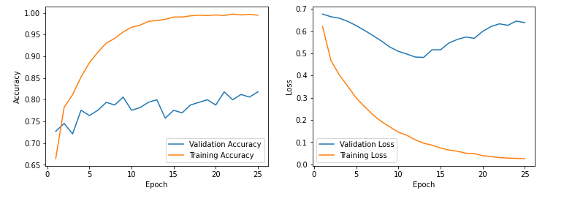
You can probably notice overfitting happening here. Let’s see if we can alleviate this using augmentation.
I am going to use the flow() method to augment the images on the fly. You can use other methods discussed in the previous section. We will be applying the following augmentation techniques to the training images.
# Augmentation
train_datagen = ImageDataGenerator(rotation_range=5, # rotation
width_shift_range=0.2, # horizontal shift
zoom_range=0.2, # zoom
horizontal_flip=True, # horizontal flip
brightness_range=[0.2,0.8]) # brightness
view rawmodel_augment_flow.py hosted with ❤ by GitHub
Train the Model
Finally, let’s train our model and see if the augmentations had any positive impact on the result!
# Epochs
epochs = 25
# Batch size
batch_size = 32
history = model.fit(train_datagen.flow(x_train,y_train,
batch_size=batch_size,
seed=27,
shuffle=False),
epochs=epochs,
steps_per_epoch=x_train.shape[0] // batch_size,
validation_data=(x_test,y_test),
verbose=1)
view rawmodel_fit_generator.py hosted with ❤ by GitHub
After 25 epochs we get the following loss and accuracy for the model on the augmented data.
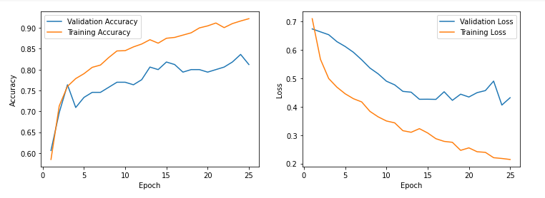
As you can notice here, the training and validation loss are both decreasing here with little divergence as compared to the outcome from the previous model. Also, notice how the training and validation accuracy is increasing together. They are comparatively closer than before the augmentation.
Such is the power of augmentation that our model is able to generalize on the images now!
I urge you to experiment around with this dataset yourself and see if you can improve the accuracy of the model!

Why Use Data Augmentation?
- Increased Dataset Size: By creating new samples from the existing data, data augmentation effectively increases the size of the dataset, which can lead to better model performance.
- Regularization: Data augmentation introduces additional variations in the data, which can help prevent overfitting by providing the model with a more diverse set of examples.
- Improved Generalization: By exposing the model to a wider range of variations in the data, data augmentation helps the model generalize better to unseen examples.
Common Data Augmentation Techniques
- Rotation: Rotate the image by a certain angle (e.g., 90 degrees, 180 degrees).
- Translation: Shift the image horizontally or vertically by a certain distance.
- Scaling: Enlarge or shrink the image by a certain factor.
- Flipping: Flip the image horizontally or vertically.
- Shearing: Skew the image along the x or y-axis.
- Zooming: Zoom in or out of the image.
- Brightness Adjustment: Increase or decrease the brightness of the image.
- Contrast Adjustment: Increase or decrease the contrast of the image.
- Noise Addition: Add random noise to the image.
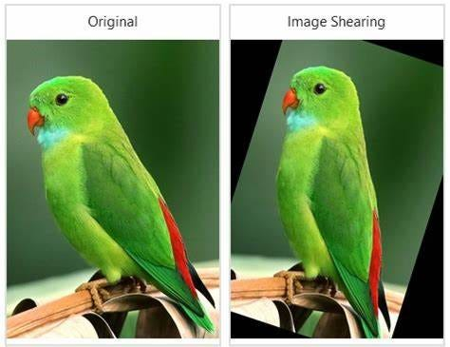
Code Example
Here’s an example of how to use data augmentation with Keras, a popular deep learning library in Python:
from tensorflow.keras.preprocessing.image import ImageDataGenerator
# Define the data augmentation parameters
datagen = ImageDataGenerator(
rotation_range=20,
width_shift_range=0.1,
height_shift_range=0.1,
shear_range=0.2,
zoom_range=0.2,
horizontal_flip=True,
vertical_flip=True,
fill_mode='nearest'
)
# Load the original image
img = load_image('path/to/image.jpg')
# Reshape the image to a 4D tensor with shape (1, height, width, channels)
img = img.reshape((1,) + img.shape)
# Generate augmented images
augmented_images = []
for batch in datagen.flow(img, batch_size=1):
augmented_images.append(batch[0])
if len(augmented_images) >= 5:
break # Stop the loop after generating 5 augmented images
# Display the original and augmented images
for i, img in enumerate(augmented_images):
plt.subplot(1, 5, i+1)
plt.imshow(img)
plt.axis('off')
plt.show()
Cats vs dogs classification using data augmentation
import tensorflow as tf
from tensorflow.keras.preprocessing.image import ImageDataGenerator
from tensorflow.keras.models import Sequential
from tensorflow.keras.layers import Conv2D, MaxPooling2D, Flatten, Dense
# Define the data augmentation parameters
datagen = ImageDataGenerator(
rescale=1./255,
rotation_range=20,
width_shift_range=0.1,
height_shift_range=0.1,
shear_range=0.2,
zoom_range=0.2,
horizontal_flip=True,
vertical_flip=True,
fill_mode='nearest'
)
# Load the training and validation datasets
train_ds = datagen.flow_from_directory(
'path/to/training_data',
target_size=(150, 150),
batch_size=32,
class_mode='binary'
)
val_ds = datagen.flow_from_directory(
'path/to/validation_data',
target_size=(150, 150),
batch_size=32,
class_mode='binary'
)
# Define the CNN model
model = Sequential([
Conv2D(32, (3, 3), activation='relu', input_shape=(150, 150, 3)),
MaxPooling2D((2, 2)),
Conv2D(64, (3, 3), activation='relu'),
MaxPooling2D((2, 2)),
Conv2D(128, (3, 3), activation='relu'),
MaxPooling2D((2, 2)),
Flatten(),
Dense(128, activation='relu'),
Dense(1, activation='sigmoid')
])
# Compile the model
model.compile(optimizer='adam', loss='binary_crossentropy', metrics=['accuracy'])
# Train the model
history = model.fit(train_ds, validation_data=val_ds, epochs=10)
# Evaluate the model on the test data
test_ds = datagen.flow_from_directory(
'path/to/test_data',
target_size=(150, 150),
batch_size=32,
class_mode='binary'
)
test_loss, test_acc = model.evaluate(test_ds)
print(f'Test accuracy: {test_acc}')

🔧 How Data Augmentation Works (Step-by-Step)
We’ll start with a single image, then move to augmenting a folder of images.
Press enter or click to view image in full size
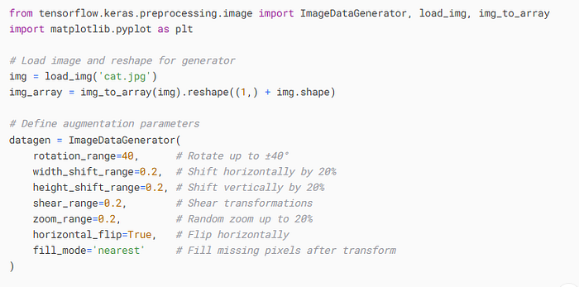
Press enter or click to view image in full size
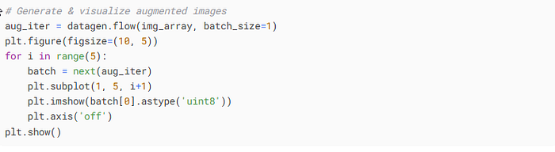
🔍 Explanation:
- ImageDataGenerator: applies the augmentations.
- img_to_array: converts PIL image to array.
- .reshape((1,) +img.shape): reshapes the image for the generator (expects 4D input: (batch, height, width, channels)).
- flow(): creates an iterator to generate batches of augmented images.
- next(aug_iter): gets the next augmented image.
📁 Folder Structure Before Applying Augmentation on entire Folder:
Before applying augmentation using flow_from_directory, your folder should be organized like this:
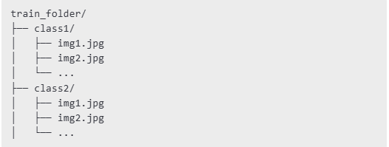
Each subfolder represents a class, and images belonging to that class are stored inside it. This structure allows ImageDataGenerator.flow_from_directory() to automatically label the images based on their folder name.
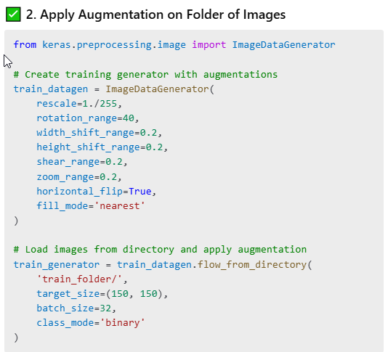
🔍 Why rescale=1./255?
- Neural networks work better with normalized inputs.
- 1./255 scales pixel values from 0–255 to 0–1.
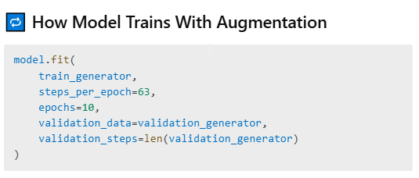
What happens behind the scenes:
- Suppose you have 1000 original images, and batch_size = 16
- You get: steps_per_epoch = 63 (because 1000 / 16 ≈ 63)
- Every epoch, the generator loads batches of augmented images.
- Total images per epoch: 63 × 16 = 1008 augmented images
- For 10 epochs: 1008 × 10 = 10,080 total augmented samples
But wait — what about original images?
- Your 1000 original images are reused in every epoch, but every time with new transformations.
- So while base images are the same, the model sees different versions each time.
Manual steps_per_epoch?
- Yes! The generator creates infinite batches, so you must manually stop after the correct number.
- Even though len(train_generator) can return a value, it’s safer to compute manually using:
steps_per_epoch = total_images // batch_size
🧠 What If You Want Both Original + Augmented Images?
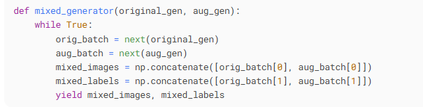
Then train using:
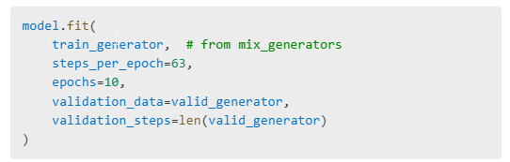
Why mix original and augmented?
- Some augmentations distort patterns.
- Pure augmented data might confuse the model.
- Original images reinforce base patterns, while augmented ones promote generalization.
Want to reduce overfitting further?
- ✅ Use strong augmentations
- ✅ Add Dropout layers in your CNN
- ✅ Use EarlyStopping callback
❓ Does This Cause Overfitting?
Common Question:
If we reuse 1000 original images over 10 epochs and apply augmentation, could it lead to overfitting?
No.
Why?
- You’re not feeding exact duplicates.
- Each time, the generator transforms them differently.
- The model doesn’t memorize exact patterns but learns invariant features.
However, if you repeatedly feed unaltered images, overfitting will occur.

